Automating a Python Application Build using Jenkins

1)create app.py   
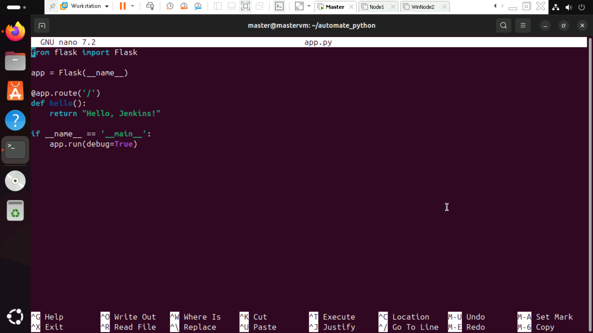

2)create a requirements.txt file

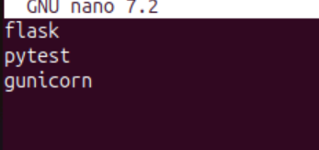

3)create a tests folder in that create test_sample.py

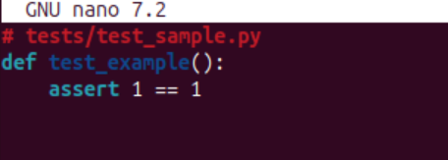

4)create a Jenkinsfile

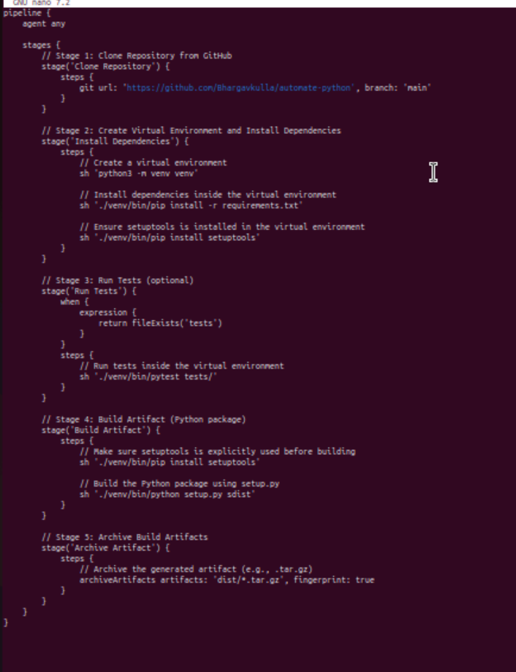

5)Final output

